KVR GOVERNMENT DEGREE COLLEGE FOR WOMEN (A)
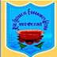

Accredited ‘A’ Grade by NAAC

(Affiliated to Rayalaseema University)

Near Railway Station, Kurnool.

------------------------------------------------------------------------------------------------------------------------------------------

Name of the Employee: G. Deva Kumari 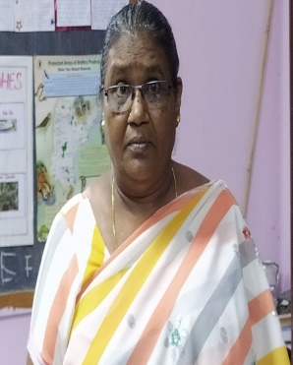
Qualification: SSc
Designation: Attender
Employee ID: 09423
Department working: Zoology
Date of Birth: 02-06-1971
Date of Joining: 19-09-2008
Experience: 14 years
Phone no: 7893165877

